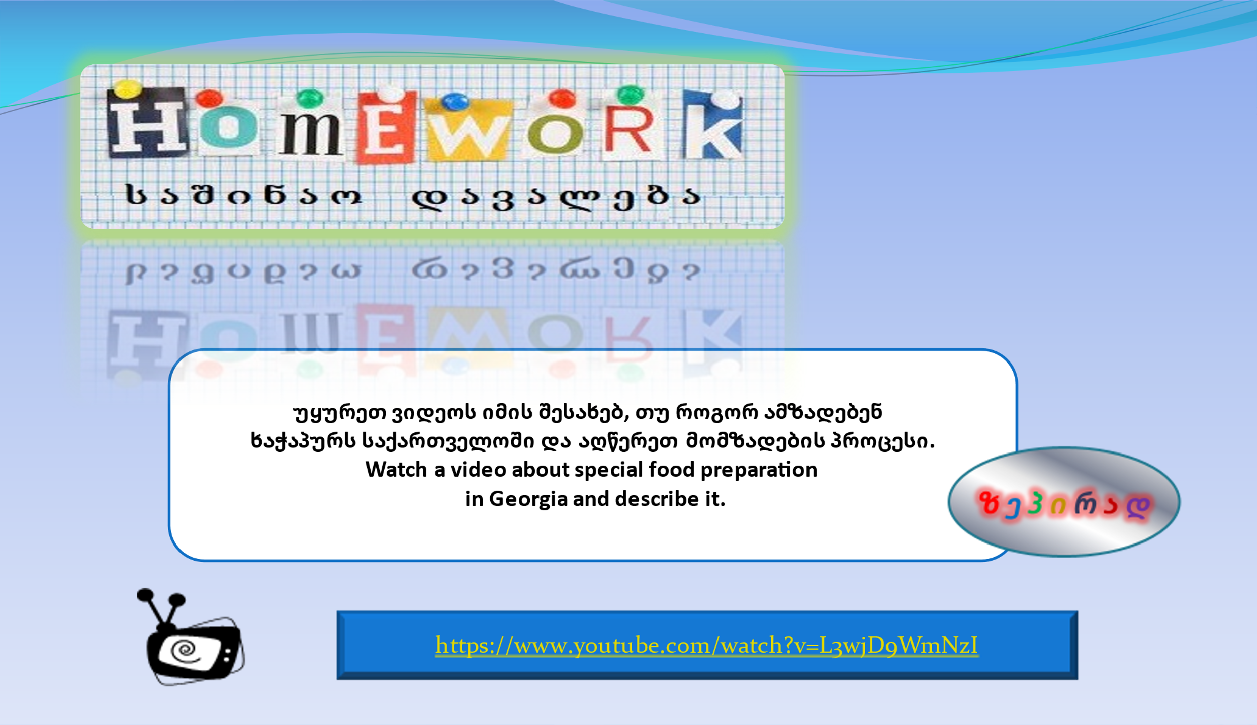
https://www.youtube.com/watch?v=L3wjD9WmNzI

