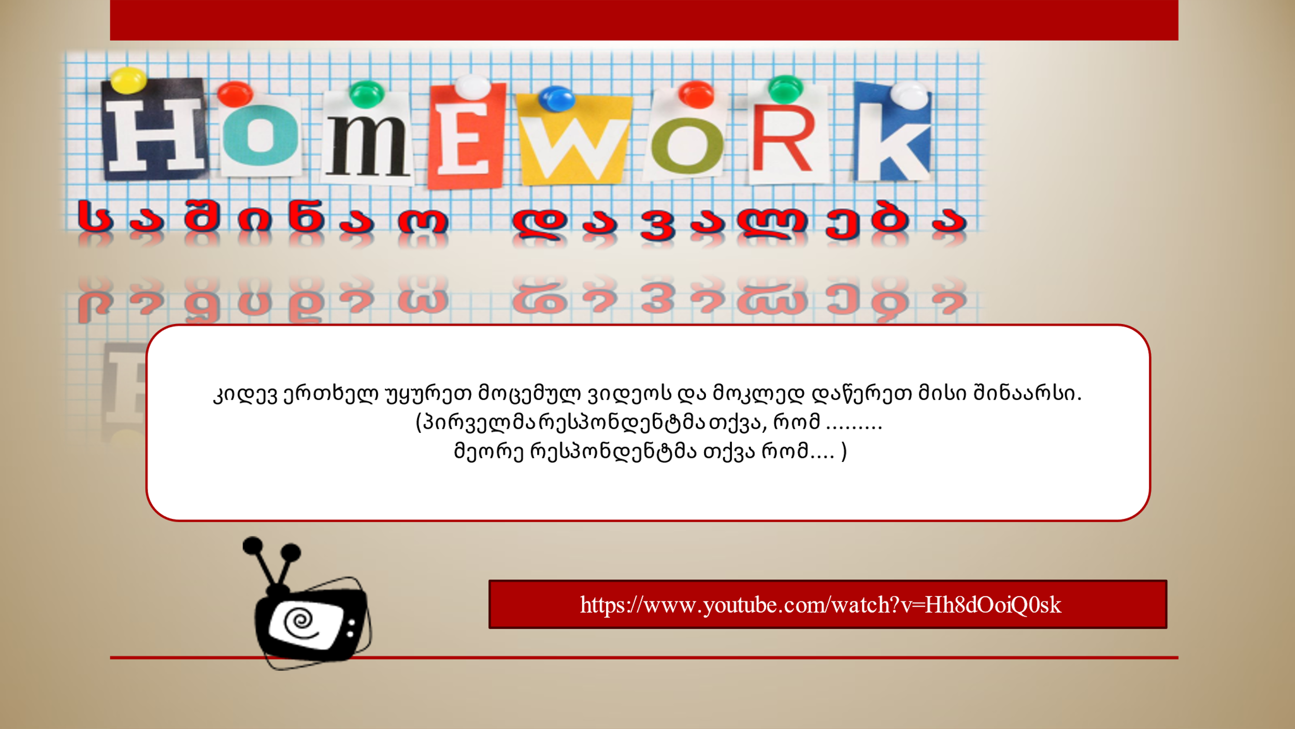
https://www.youtube.com/watch?v=Hh8dOoiQ0sk

